
QUALITY ALERT

Customer: HPAC Date: August 16, 2021
Die: 15191 / 15192 / 15238 Colour: ALL
Type of Complaint: HPAC REJECT

Q.A # Q.I.R # CUSTOMER NCR #

Description: Panels marked for scrapped were shipped to the customer
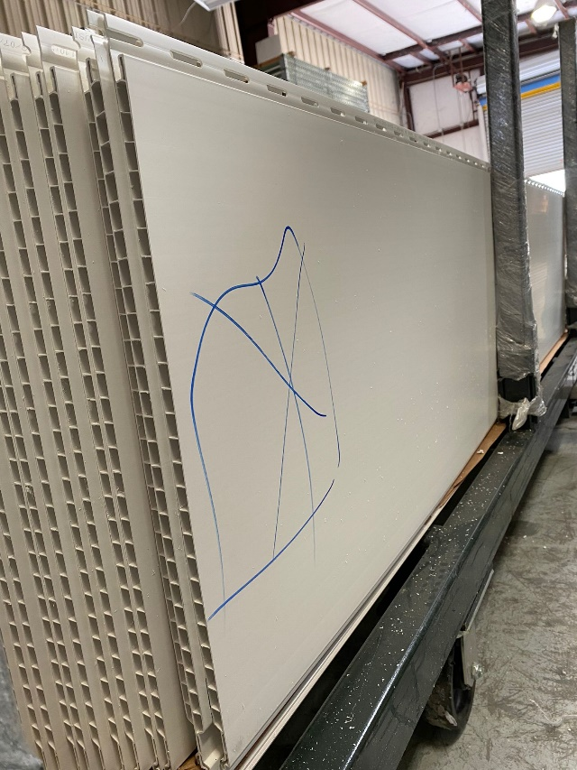
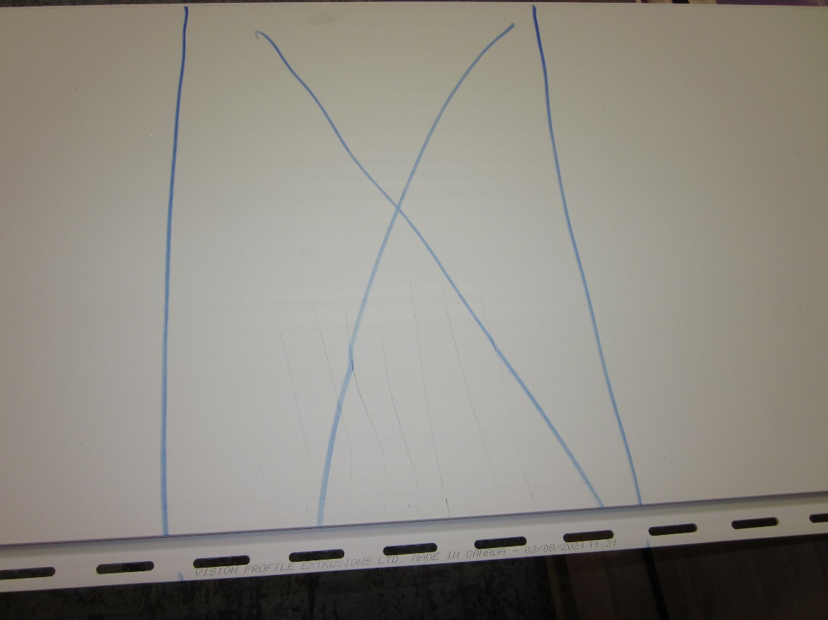

DO NOT PACK THE MARKED PANELS
BY SIGNING BELOW, YOU ACKNOWLEDGE THE PROBLEM ABOVE AND AGREE TO MONITOR THIS ISSUE IN FUTURE PRODUCTION RUNS.
DAY SHIFT |  | AFTERNOON SHIFT |  | NIGHT SHIFT
NAME | SIGNATURE | NAME | SIGNATURE | NAME | SIGNATURE

